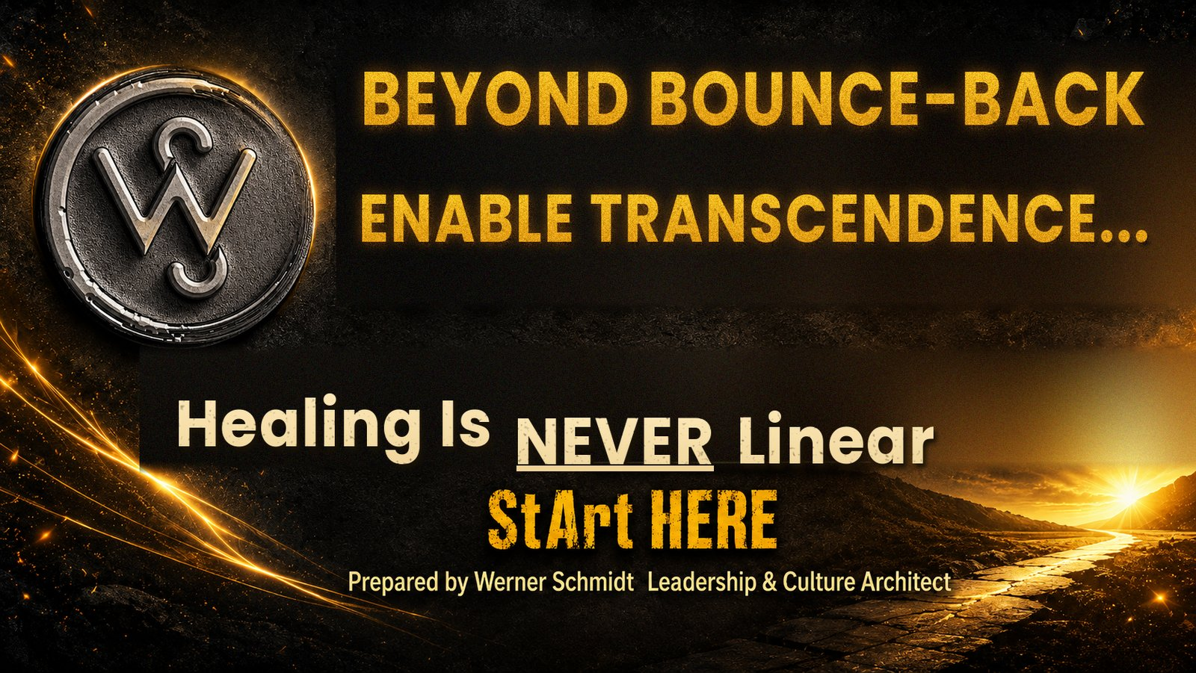https://WernerSchmidt.co.za info@wernerschmidt.co.za +2764 141 4341
Appointments (first conversation free-of-charge): https://bit.ly/YourCoffeeWithWerner

Your Beyond Recovery Workbook
Companion to Healing From Burnout: Beyond Bounce-Back... Enable Transcendence — Read the full article HERE [insert Article 2 link once published]
This workbook turns the Beyond Bounce-Back framework into daily practice. Work through it once you already know, from Your Burnout Early-Warning Checklist, that a redesign is needed. There are no wrong answers here, only honest ones.
WHICH BURNOUT PATTERN IS YOURS? SELF-LEADERSHIP STARTING POINT
Statement | Yes | No
PERSONALITY UNDER PRESSURE (EXPRESSED PERSONAL CULTURE)
I cannot let a scoreboard, a metric, or a competitor go unwatched.
I feel unsafe unless I am building or controlling something bigger, faster.
I would rather implode privately than ask for help.
I stay fiercely independent, even when real support is offered.
Formulate your pattern, if not addressed above.
ENVIRONMENT UNDER PRESSURE (ORGANISATIONAL CULTURE)
My organisation rewards ever-greater performance without matching wellbeing development.
Wellbeing here is a webinar or a poster, not a redesigned system.
I am expected to recover briefly, then return to the same system unchanged.

FIND YOUR FOUR Ms
Write your own answer under each one.
+ Meaning. What kind of work matters to you, beyond the paycheck and the title?

+ Mastery. Where do you have autonomy to master your greatest talents? Describe said talents.

+ Market. Who genuinely needs what you can offer, in your particular shape?

+ Money. What honest value exchange lets you keep doing this while increasingly enjoying what you do?

BUILD YOUR EVER-VESCENCE RHYTHM
Daily rhythm | Practising it | Needs work
Rest
Eat
Move
Work
Love
Play
Converse well
Self-love and community building

YOUR FOUR RECOVERY EXPERIENCES, DAILY
Recovery experience | Mon | Tue | Wed | Thu | Fri | Sat | Sun
Psychological detachment from work
Real relaxation
A mastery experience outside work stress
Genuine control over your own time

Give yourself permission for your Beyond Recovery timeline to be long enough.
Healing is essential. Transcendence is a decision, practiced daily.
Regularly contemplate and journal your way through your Transcend Beyond Bounce-Back journey.
From work hard, play hard, to work well, rest well, play well, eat well, relate well, be well, do well, feel well. Repeat.
Feel free to contact Werner: +2764 141 4341
Appointments (first conversation free-of-charge): https://bit.ly/YourCoffeeWithWerner

