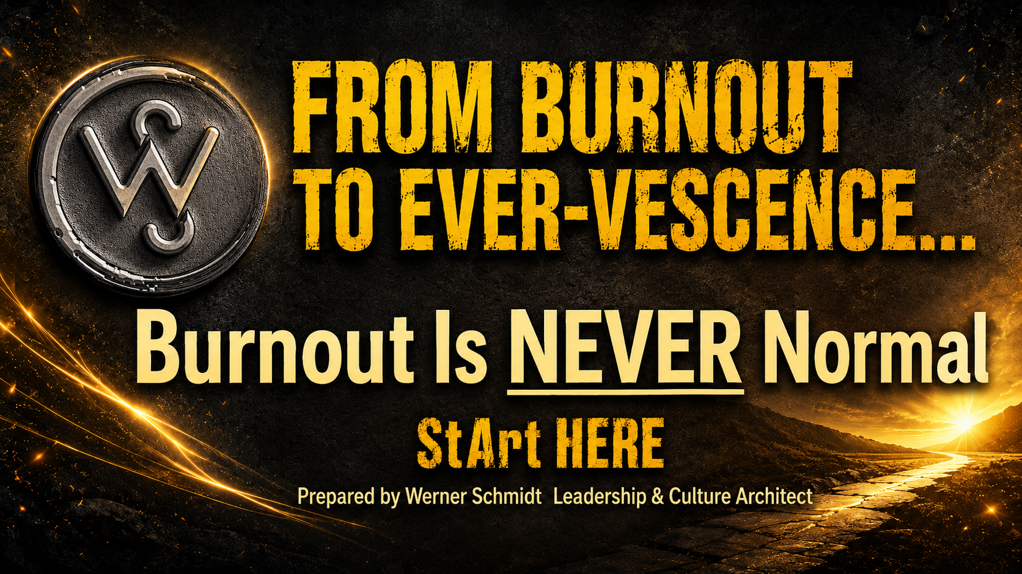
https://WernerSchmidt.co.za info@wernerschmidt.co.za +2764 141 4341
Appointments (first conversation free-of-charge): https://bit.ly/YourCoffeeWithWerner

Your Burnout Early-Warning Checklist
Mark YES or NO in the right-hand column. Several warning signs do not confirm burnout, but they do signal that honest conversation, support, or life and/or career redesign may be needed.
BURNOUT IS NEVER NORMAL: EARLY-WARNING CHECKLIST
Burnout symptom or signal | Yes | No
HEAD: THINKING AND FOCUS
I am working longer hours per day, and per week, and achieving increasingly less.
Tasks that once felt simple now consume excessive time.
I reread messages, postpone decisions, or jump and bounce between unfinished tasks.
My concentration, judgement, creativity, or memory feels weaker.
My unread emails and unfinished responsibilities keep multiplying, spiralling out of control.
I get increasingly cynical, detached, or negative about my work.
I struggle to see the meaning of what I am doing.
HEART: ENERGY AND RELATIONSHIPS
I feel emotionally exhausted, even after attempting to rest or sleep.
Irritability is leaking into my professional and/or personal relationships.
Ordinary questions, interruptions, or feedback feel intrusive.
The people around me appear to be walking on eggshells when I’m around.
Compassion is thinning. Judgment and scorekeeping is increasing.
I am withdrawing emotionally while remaining professionally visible.
I keep asking, “Does any of this still matter?”
HANDS: HABITS AND ACTIONS
Coffee and/or other stimulants have become my morning ignition system.
Food, alcohol, medication, scrolling, shopping, or overworking help me cope with the day.
I need something external to lift me up, carry me through, or bring me down.
I remain busy, yet complete increasingly less meaningful work.
I avoid difficult conversations, decisions, or responsibilities.
Weekends or holidays provide only brief relief. It takes me days to find some relaxation, once on leave.
My body is sending recurring messages through fatigue, tension, poor sleep, headaches, appetite changes, or digestive discomfort.
ROLE AND CULTURE: WHAT MAY NEED REDESIGN
My role no longer contains enough meaning.
I have too little autonomy or room for mastery.
My best contribution is underused or unseen.
My workload, responsibilities, and available resources are misaligned.
Damaging relationships or unresolved conflict are consuming energy.
Wellbeing exists as an add-on rather than being integrated into daily work.
Constant availability, overload, and performative urgency have become normal.
I am expected to recover briefly, then return to the same system unchanged.
If several red flag signals are present, do not wait for collapse. Speak to someone you trust and seek appropriate professional, organisational, or medical support.
Burnout is not weakness. Burnout is information, a signal.
Listen to your body before the whisper becomes a shutdown.

Feel free to contact Werner: +2764 141 4341
Appointments (first conversation free-of-charge): https://bit.ly/YourCoffeeWithWerner

